In the matlab command line type “eeglab” and press enter

To extract eeglab data from the Brain Products recording files:

Select File > Import Data > Using EEGLAB functions and plugins > From Brain Vis. Rec. .vhdr file

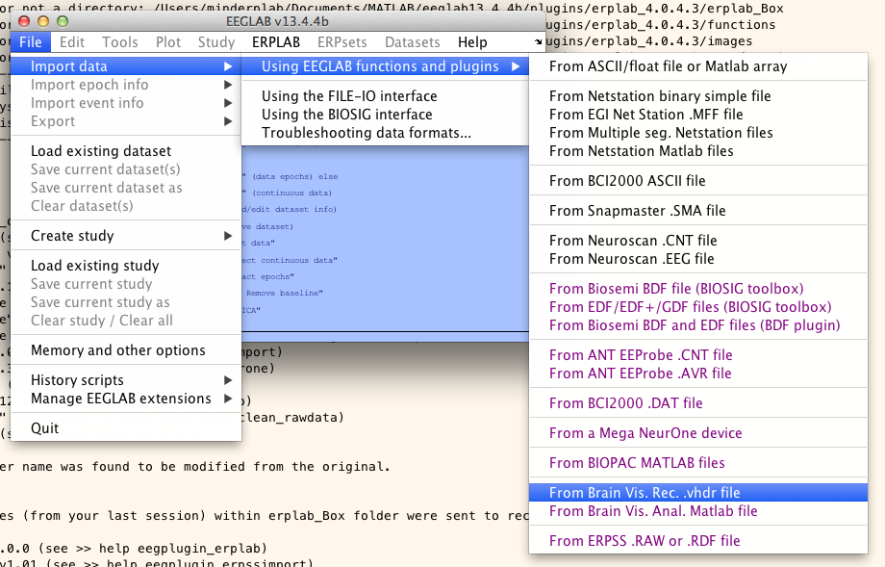

Navigate to the appropriate folder:

* For DT: REDWOOD/Blackbird/Intern Folder/ERP/160907-/DT/[participant id number, i.e., 173]
* For eDT_angry: REDWOOD/Blackbird/Intern Folder/ERP/160907-/eDT_angry/[participant id number, i.e., 173]
* For eDT_happy: REDWOOD/Blackbird/Intern Folder/ERP/160907-/eDT_happy/[participant id number, i.e., 173]
* For eDT_calm: REDWOOD/Blackbird/Intern Folder/ERP/160907-/eDT_calm/[participant id number, i.e., 173]
* For eGNG_faces_angry: REDWOOD/Blackbird/Intern Folder/ERP/160907-/eGNG_faces_angry/[participant id number, i.e., 173]
* For eGNG_faces_happy: REDWOOD/Blackbird/Intern Folder/ERP/160907-/eGNG_faces_happy/[participant id number, i.e., 173]
* For eGNG_IAPS_negative: REDWOOD/Blackbird/Intern Folder/ERP/160907-/eGNG_IAPS_negative/[participant id number, i.e., 173]
* For eGNG_IAPS_positive: REDWOOD/Blackbird/Intern Folder/ERP/160907-/eGNG_IAPS_positive/[participant id number, i.e., 173]
* For GNG: REDWOOD/Blackbird/Intern Folder/ERP/160907-/GNG/[participant id number, i.e., 173]

Select the file:

* For DT start with: DT_blue_session1_[participant id number, i.e., 173]
* For eDT_angry start with: eDT_Angry_Session1_[participant id number, i.e., 173]
* For eDT_calm start with: eDT_Calm_Session1_[participant id number, i.e., 173]
* For eDT_happy start with: eDT_Happy_Session1_[participant id number, i.e., 173]
* For eGNG_faces_angry start with: eGNG_Angry_Session1_[participant id number, i.e., 173]
* For eGNG_faces_happy start with: eGNG_Happy_Session1_[participant id number, i.e., 173]
* For eGNG_IAPS_negative start with: eGNG_IAPS_negative_Session1_[participant id number, i.e., 173]
* For eGNG_IAPS_positive start with: eGNG_IAPS_positive_Session1_[participant id number, i.e., 173]
* For GNG start with: GNG_Session1_[participant id number, i.e., 173]

The “Load a Brain Vision Data Exchange format dataset” window appears. Enter nothing beside Interval, and 1:34 beside Channels.

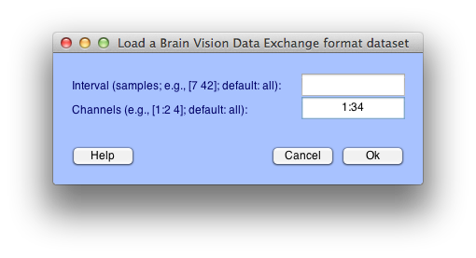

You will be asked to name the dataset, give it the same name it previously had (i.e., “eDT_Happy_Session1_[participant id number, i.e., 173]”)

Repeat for all sessions in folder.

* For DT there are 6 sessions
* For eDT_angry there are 2 sessions
* For eDT_calm there are 2 sessions
* For eDT_happy there are 2 sessions
* For eGNG_faces_angry there are 5 sessions for CARPP participants, 2 sessions for BETTA participants
* For eGNG_faces_happy there are 5 sessions for CARPP participants, 2 sessions for BETTA participants
* For eGNG_IAPS_negative there are 2 sessions
* For eGNG_IAPS_positive there are 2 sessions
* For GNG there are 5 sessions for CARPP participants, 2 sessions for BETTA participants

Note, after the first file the name dataset dialogue box will look like this. You only need to fill out the first field.

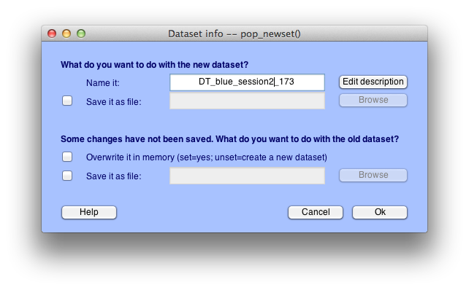

Go to edit > append datasets

* For DT enter 1:6 in the dialogue box and press “okay”
* For eDT_angry enter 1:2 in the dialogue box and press “okay”
* For eDT_calm enter 1:2 in the dialogue box and press “okay”
* For eDT_happy enter 1:2 in the dialogue box and press “okay”
* For eGNG_faces_angry enter 1:5 or 1:2 (depending on number of sessions) in the dialogue box and “okay”
* For eGNG_faces_happy enter 1:5 or 1:2 (depending on number of sessions)in the dialogue box and “okay”
* For eGNG_IAPS_negative enter 1:2 in the dialogue box and press “okay”
* For eGNG_IAPS_positive enter 1:2 in the dialogue box and press “okay”
* For GNG enter 1:5, or 1:2 (depending on number of sessions)in the dialogue box and press “okay”

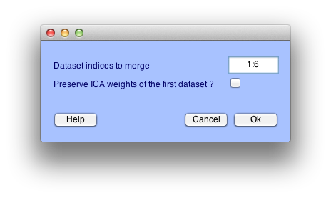

Name it with the task and participant id, e.g., DT_173

IMPORTANT!!! File > Save Current Dataset As

Name after task and participant id i.e., DT_173

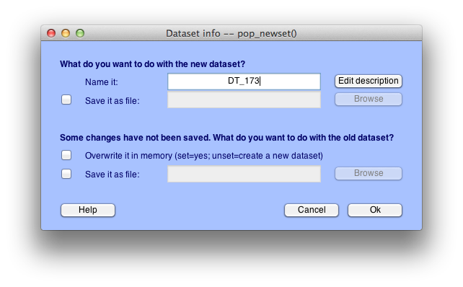

Click the script in Matlab (ERPPreprocessing1)

Click the big green arrow to run

If a dialogue box appears, select “add to path”

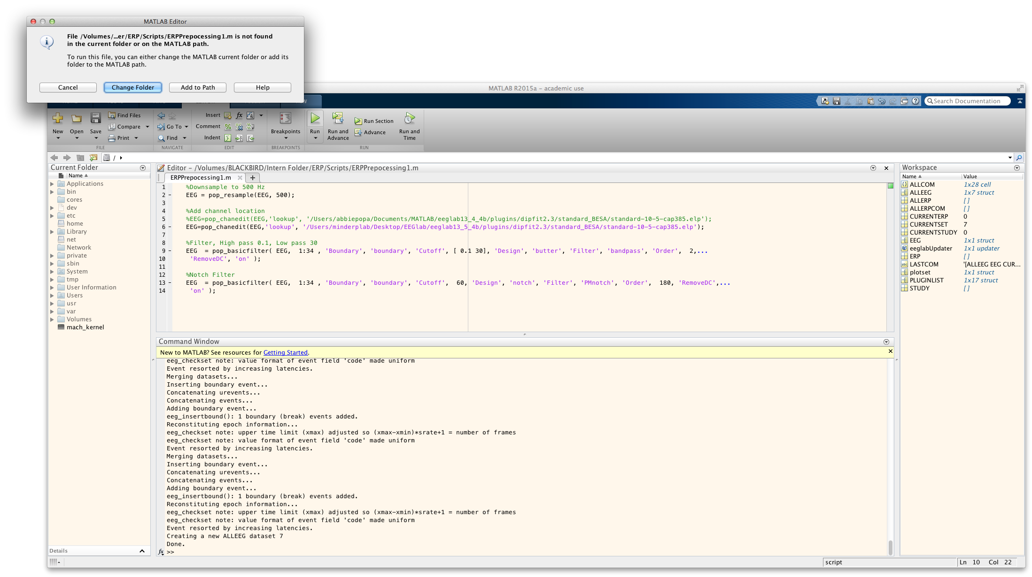

IMPORTANT!!! File > Save Current Dataset As

Name after task and participant id with “preproc1” at the end. i.e., DT_173_preproc1

If you are not also completing artifact rejection close eeglab here and begin at the beginning! This will ensure you apply changes to the correct datasets. Do NOT start at the beginning without first closing EEGlab.

To complete artifact rejection:

File > Load existing dataset

Select the dataset that ends in “preproc1”

Plot > Channel Data (scroll)

Highlight regions to reject

If you are approved to reject without Abbie’s approval, click “reject”

Rename with task, participant id, and AR. i.e., “DT_180_AR”

Save as task, participant id, and AR. i.e., “DT_180_AR”

***The next step is to run ICA on the AR dataset. However, since ICA can take up to 8 hours to run, Abbie will do this rather than asking the interns to do it!***

Going from EEG to ERP!

For the preman script to work the current folder MUST be the folder for the participant you are working on. For example if you are running preman on eDT calm for 981, your matlab window would look like this. Note the current folder (red circle) and folder contents (green circle).

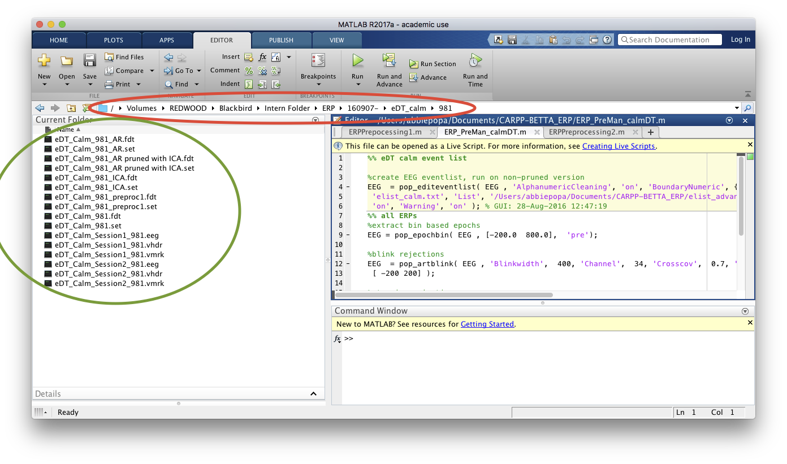

Double check that you have the preman script open that applies to your task, in this case I am doing “calmDT.” This should also be the “active” script, so the tab will be a lighter shade of gray. (See blue circle.)

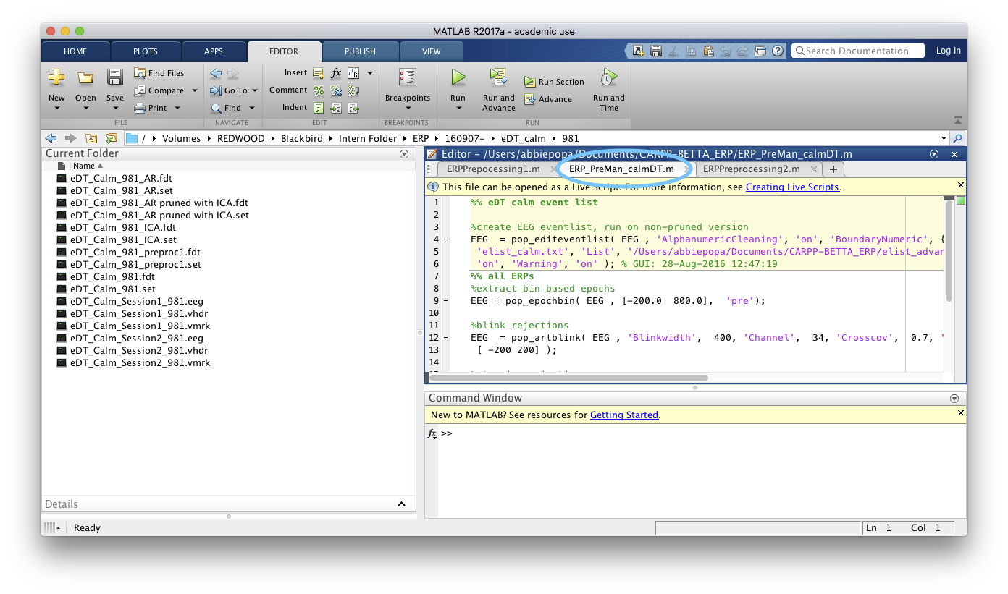

run EEGlab by typing “eeglab” in the command window and pressing enter

File > Load existing dataset

Select the dataset ending in “AR”

Click in the PreMan script and click the big green “run” arrow

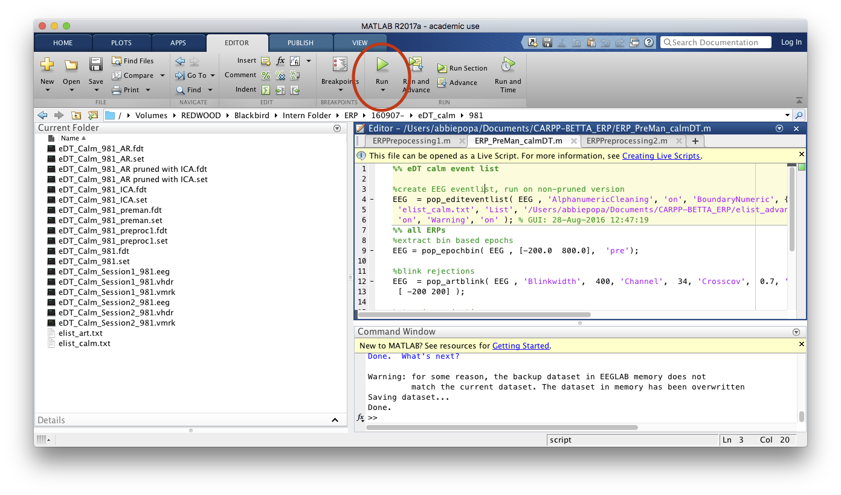

If prompted select “Add to path.” (if not prompted don’t worry about it)

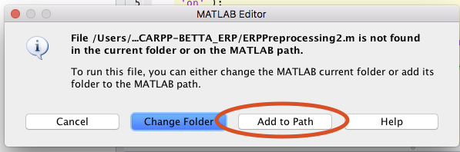

In the first (yellow) window choose “overwrite”

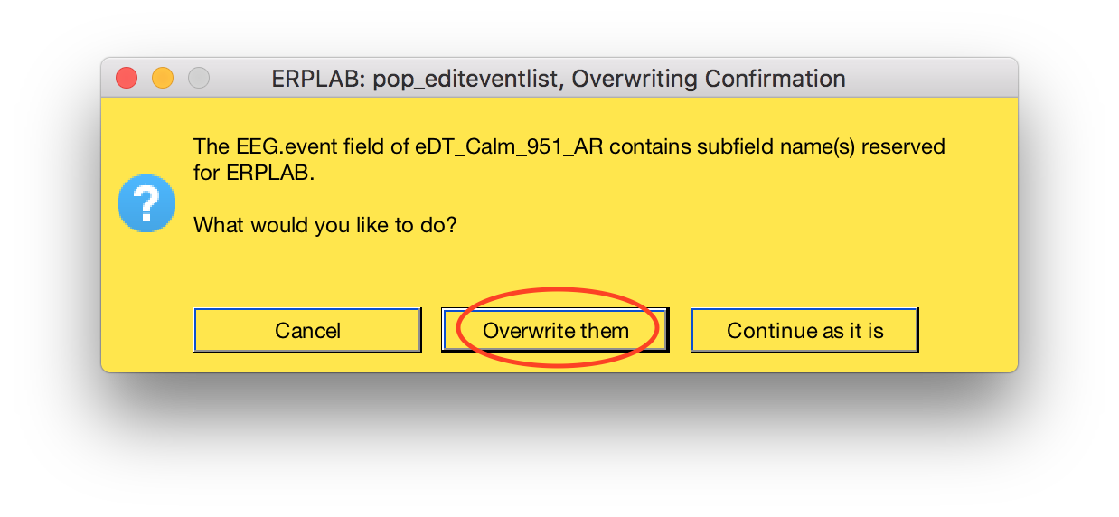

In the second (blue/grayish) window choose “code labels”

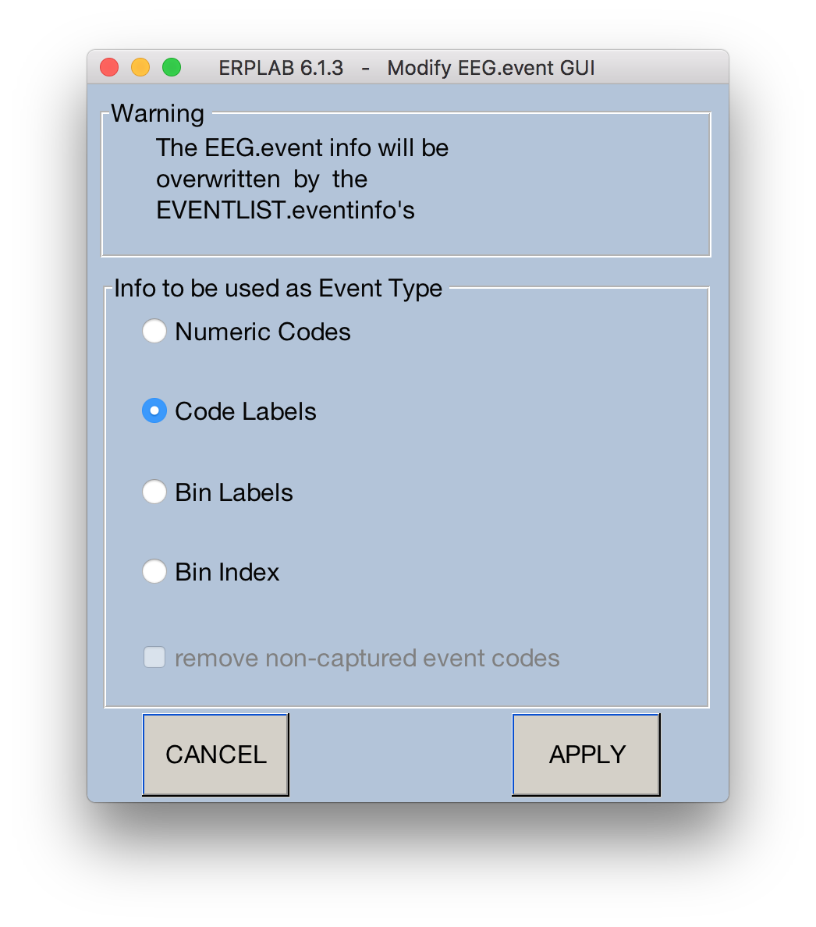

Important!!! File > Save current dataset as

Name it [TASK]_[id#]_preman, for example eDT_Calm_981_preman

Next select the tab for “ERPPreprocessing2.m” it will turn light gray

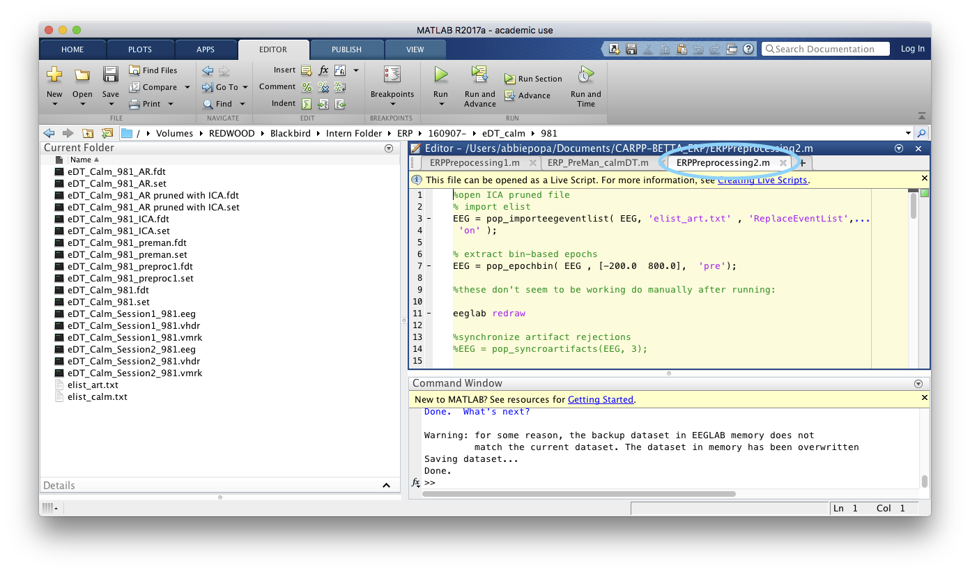

File > Load existing datset

For 95% of participants select the file ending in “pruned with ICA”

If there is no “pruned with ICA” file AND there is a text file named “pruned.txt” in the folder instead select the file ending in “_ICA”

Select the first section of the ERPPreprocessing2.m script and click “Run Section”

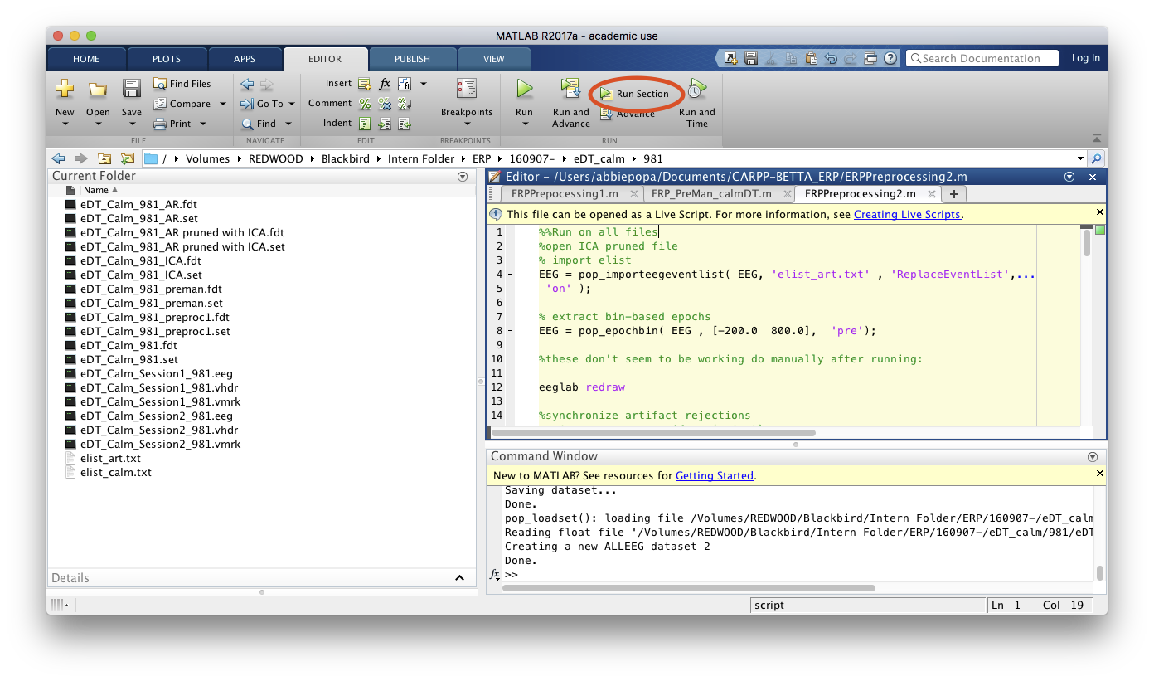

ERPLAB > Artifact detection in epoched data > Synchronize artifact info in EEG and EVENTLIST

Select the third radio button and click “ok”

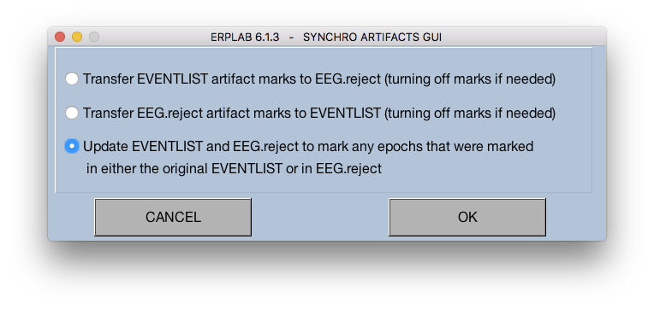

Name and save the file with “syncrej” appended. You can use the dialog box now because you are in the participants folder as your working directory.

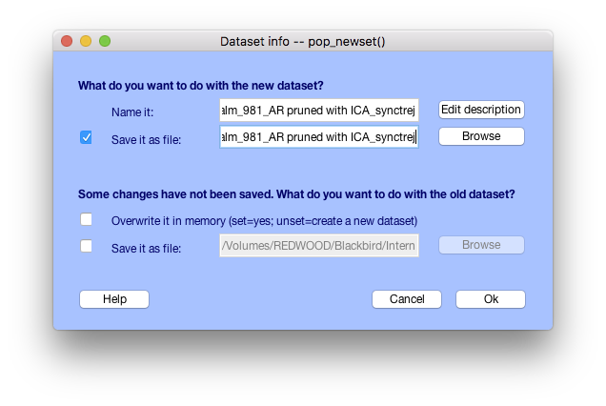

ERPLAB > Compute averaged ERPs

Use the defaults and click “RUN”

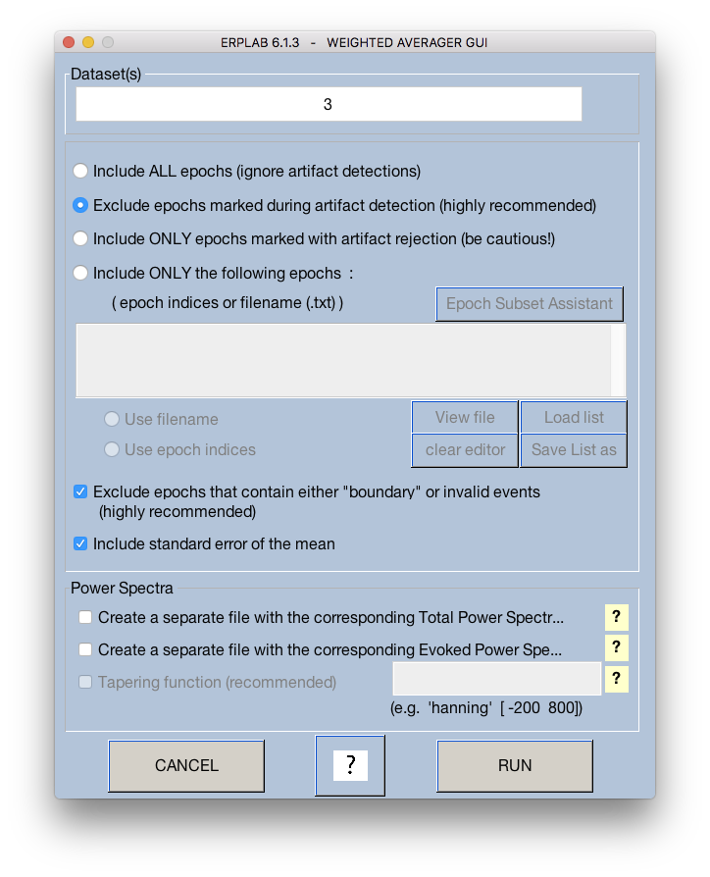

Name the file [task]_[id#]; also save it as such! For example “eDT_calm_981”

Again, you can use the dialog box to save now since you are in the proper working directory

Note, it is IMPORTANT to SAVE or your work will be lost

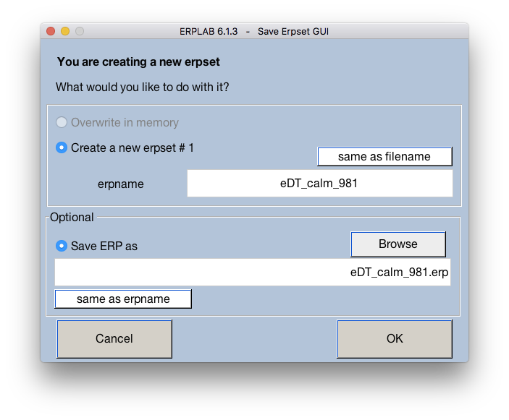

Next, scroll down in ERPPreprocessing2.m until you find the section named after the task you are currently processing. For example, since I am processing eDT calm I will scroll to “emotional ERP DT.” Select this section by clicking in it

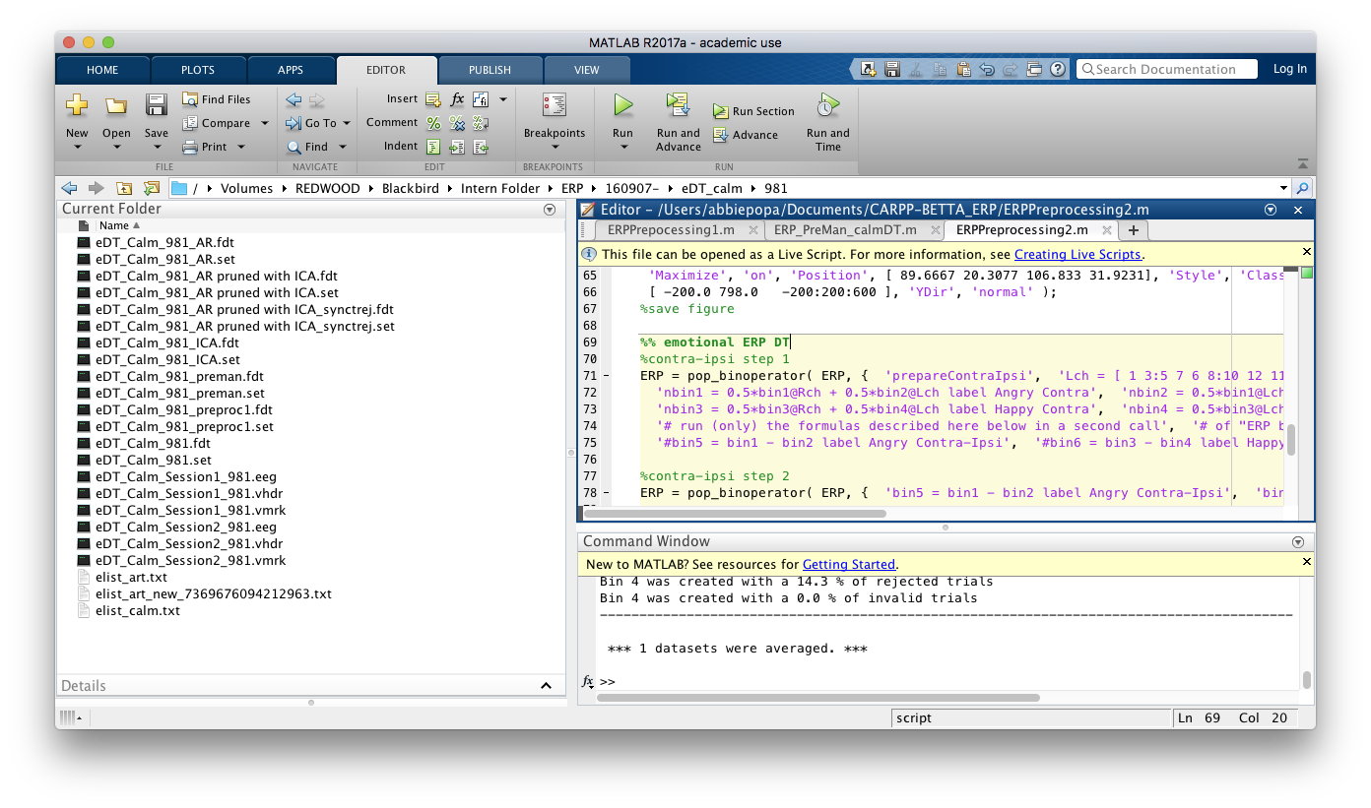

Click “Run and Advance”

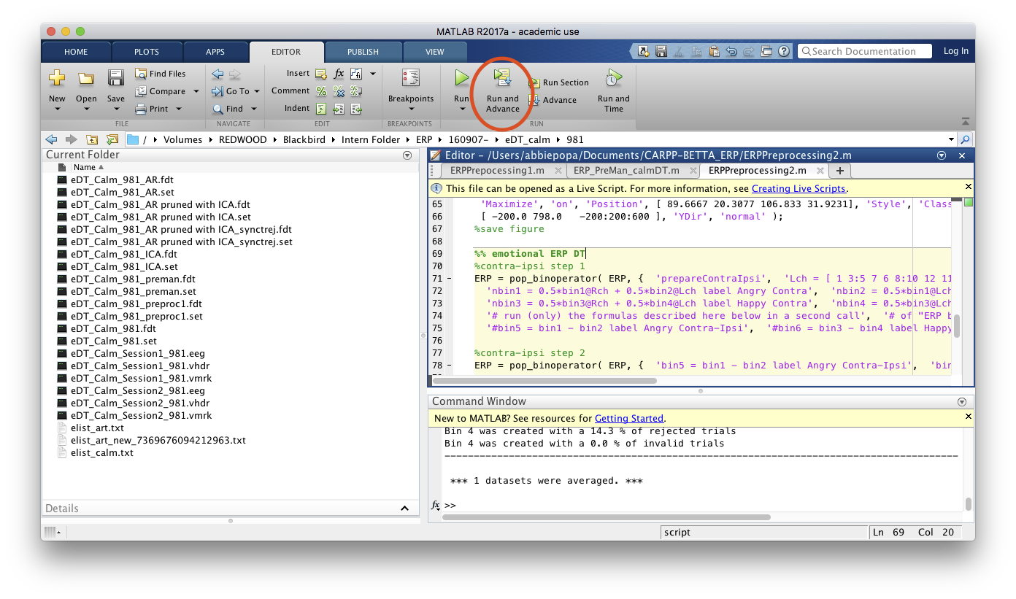

Important!! You MUST manually save the new ERPset or your recent work will be lost

ERPLAB > Save current ERPset as

If doing DT or eDT add “ci” to the end of the file name. For example “eDT_calm_981_ci”

If doing GNG or eGNG add “chop” to the end of the file name. for example “GNG_981_chop”

Your matlab window should now be in a section that begins with the word “plot.” For example since I am doing eDT_calm it says “plot eDT”

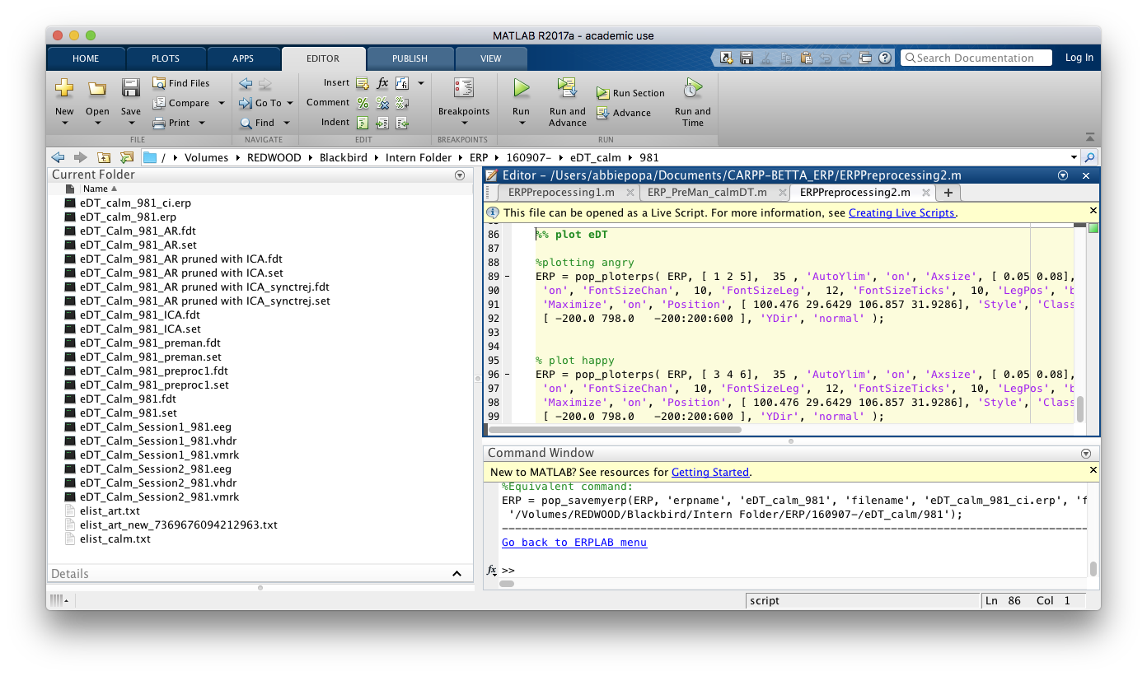

click “Run Section”

for eDT two windows will open that look like the image below. Click on the graph (circled).

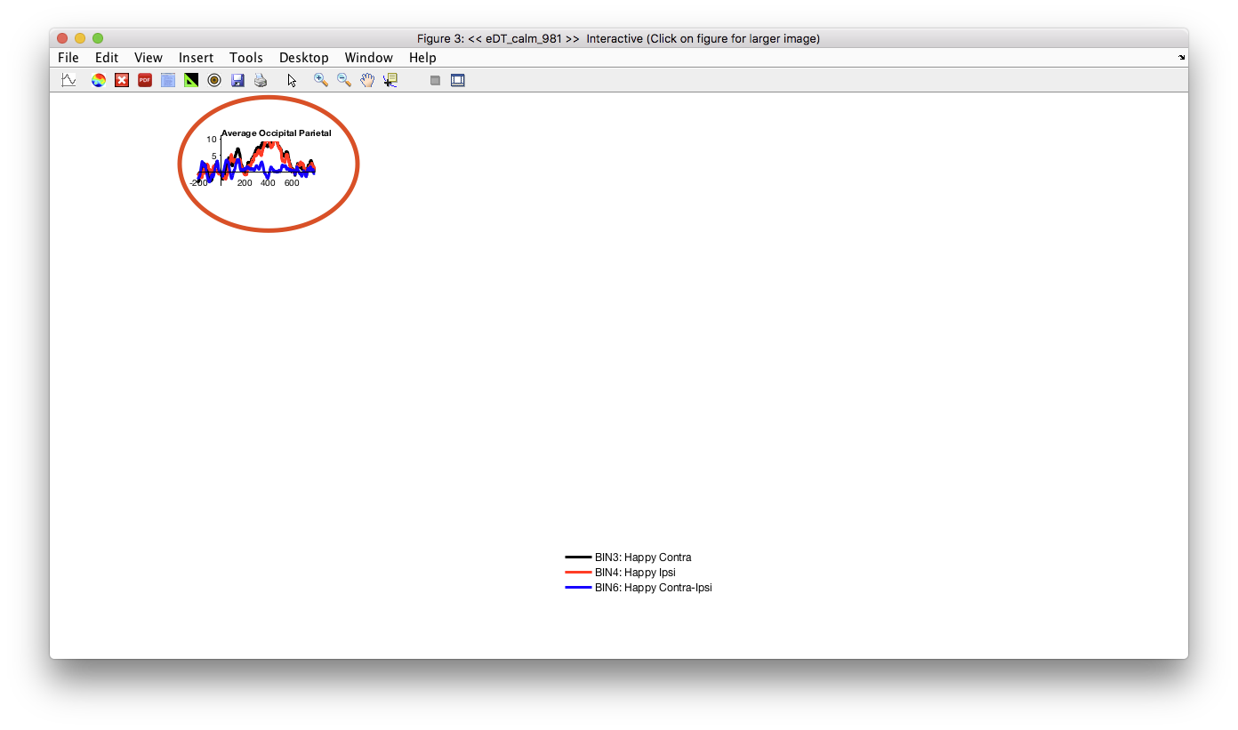

A big graph will open. Make note of the emotion in the legend (circled)

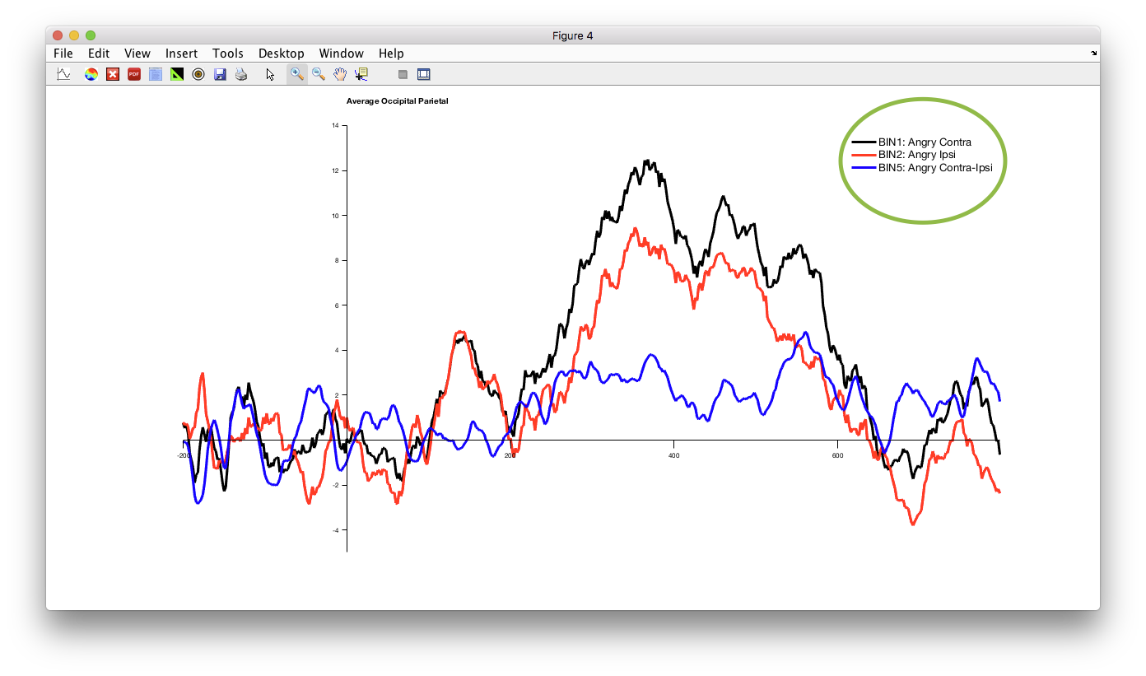

On the big graph, go to File > Save as…

Save as [task]_[id#]_[emotion from graph], for example this one is “eDT_calm_981_angry”

Make sure to save both of the graphs that opened if doing eDT!!

That concludes this participant, move on to the next! Be sure to close and reopen EEGlab before starting a new participant!!!